**HOW TO SUCCESSFULLY WRITE AND PUBLISH YOUR BOOK**

*“The role of a writer is not to say what we all can say, but what we are unable to say.”*

*- Anais Nin*

Writing is fun. Imaginative when fiction and expressive or concise when Non-fiction. Moreover, there are so many styles, Persuasive, Narrative, Expository, Descriptive and Creative. Many people want to write a bestseller, or at least something that would sell. And many people don’t even start.

It’s because some people think that they are not writers, but I think that if you have something to say and bold enough to let the world know your thoughts and your story then you already are a writer.

But for most people it’s the fear of what comes next. The part that comes after writing. Publishing your book. Yes! That’s a daunting task. It has many layers, but the most important thing is to get over the hurdle early in your writing process. Motivating yourself by knowing how other authors became successful and learning from their mistakes so that you can make less mistakes of your own.

How did they become so successful?

* Writing the book with focused approach to make it engaging, educational and transformational.
* Publishing their book right
* Developing an authority and credibility in their space
* Building their brand and business around their book

We will see these points in detail also let’s see what the 5 step approach to publishing the book is.

**The 5 step approach to Book-Publishing**

*“Novels begin, not on the page, but in meditation and day dreaming- in thinking, not writing.”-Joyce Carol Oates*

**1. The Content Structure**

**Research your market:**

Are you writing your story keeping your audience in mind? Do you know your target audience? Does your story resonate with your target audience? What would your audience want to read? Are you ready to write for your audience or just want your story to be as it is and touch your readers’ hearts?

Answering these questions can help you narrow down your field of research and can efficiently help you complete your first draft.

Now, suppose you want to write your first self-help book about overcoming anxiety in women, now imagine an extremely overwhelmed and emotional woman sitting on her bed your book in her hand and trying to understand what can she do to make everything less bearable? What words are you going to write for her to let her know that you understand her pain and that you have exactly what she wants to know?

By constantly aligning your thoughts with your readers you can achieve incredible success in your first draft itself. It won’t be perfect but you will be closer to your dream.

**Book’s anatomy:**

Writing a good story means following a format that is easy to write and also easy to read, which can give you space to be creative and put your focus on the story you want to tell.

* Exposition: Beginning of the story where characters and settings are introduced
* Climax: Outcome of the conflict and the story
* Resolution: End of the story and epilogue.

**Writing the first draft:**

*“Don’t be paralyzed by the idea that you are writing a book, just write.”*

*-Isabelle Allende*

The first draft allows the writer to explore the story and visualising your novel as a whole. To help you write your first draft efficiently you can use writing prompts that can helps give your story a structure.

Forge about editing in this step. You only need your ideas in front of you so be as creative as possible. Maybe the ideas that flow and take shape roughly can be better than what you first thought. More importantly let your soul lead you in the right direction.

**Getting the feedback from friends and readers:**

Once you complete your first draft you can relax a bit. Get outside in the Sun, do a nature walk, spend time with your family and friends, play a game or watch a movie, do what you love doing. All these things can help your mind to relax and form new neural pathways so that when you revisit your draft you have a fresh perspective on your story and characters.

Now once you finalised the draft get feedbacks from your friends and family. Ask them what they think. Get their opinion on every single thing. This is a good time to set the direction of your story or the background of your characters.

**2. Choosing the Best Title**

The best title is the one that intrigues the readers enough to buy your book. They should hook your readers and convey a little bit about the plot and tone of your book.

The most common attributes of the good titles are:

* **Short**: Considering titles that are short and sweet but intriguing is the best way to hook your audience. While one word titles are easy to narrow down your genre or tone of the book that may not be helpful for the modern search engines. Consider expanding the title a bit to two or three words.

**Example**: Atonement by Ian McEwan, It by Stephen King, Pride and Prejudice by Jane Austen, etc.

* **Evocative**: Titles that are interesting and have some word play are not easy to forget. Also it showcases your skill as a writer.

**Examples**: Trainspotting by Irvine Welsh, Mexican Gothic by Silvia Moreno-Garcia, etc.

* **Consider Genre**: Define your genre by your title. It’s definitely very direct and quirky. It sets the tone for your novel early on so when readers pick your book they know exactly what’s in store for them or may be not at all. Either way it’s a fun way to constrict your brainstorming sessions.

**Example**: Home before Dark by Riley Sager, Interview with the Vampire by Anne Rice, etc.

* **Pick a name**: Consider naming your book title by the name of one of your characters. It’s a sure way to create intrigue and personal interest in your characters and the story. It gives your story a bit of an edge and a memorable character.

**Example**: Dracula by Bram Stoker, Rebecca by Daphne du Maurier, Frankenstein by Mary Shelley, etc.

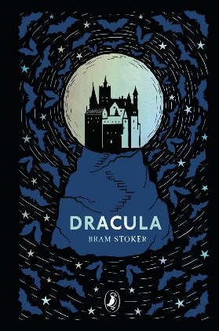 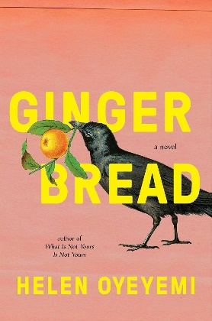

**3. Choosing the best Book Cover**

Someone once said, “Don’t judge a book by its cover”. And they were so wrong. That’s what we do anyway. It might have not mattered decades ago but in this age of Bookstagrammers and Booktubers, what you see is what you buy before reading the back cover. Even I have said it million times, “I would just buy that book for its cover”, and completely felt justified buying it.

The book cover has only one purpose to sell your book. The cover needs to show what the book is about, much like the book title but with visuals. Ask yourself:

* What the book cover should represent?
* Is it intriguing and eye catching?
* Does it stand out from other books in your category?

Keep it simple! Simplicity always works. But always go with the instinct. And investing in a good cover designer will definitely be worth it.

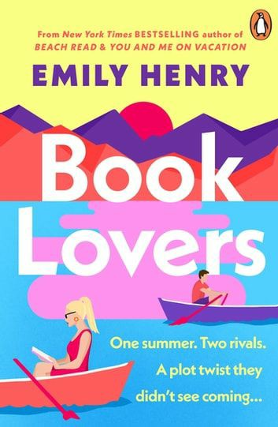 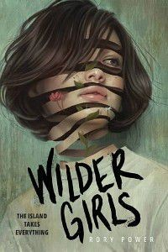 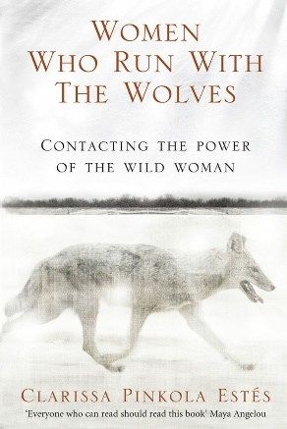 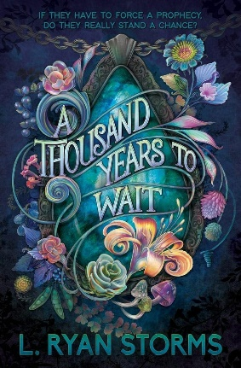

1. **Working with Experienced Team**

* **Agent**: An agent is a necessity when working with publishers. Agents are familiar with publishing industry and have many connections which can be very advantageous for writers. An agent and a writer might can develop long term goals and can strategize the writer’s career.
* **Editors** (developmental editor, line-editor, and copyeditor): When you want your book to be published the most important role played is that of the editor. So it’s always convenient to have an editor who understands your point or more importantly the point of your book.
* **Proofreader**: A proofreader makes sure your content is free of any typographical, grammatical, spelling, syntax, punctuation, formatting errors.
* **Book interior designer**: YES! You read it right. The book designer helps you with properly formatting your text to the desired shape of your paperback, hardcover, or any other type of sizing format.
* **Web designer**: A web designer is useful in creating a professional looking and an attractive website. User friendly and professional website is very convenient for marketing and promoting the book.
* **Cover designer**: As we discussed earlier, cover designs are bread and butter for the authors so it is very important that invest in a good cover designer who gets what you are going for.

1. **Marketing the Right Way**

When it comes to marketing the publishing house itself is very much invested in taking the book from manuscript level to the bestseller level. But this does not mean that the writer has no role in it. In fact, writers are the public face of their own creation and showing up is what writers need to do to take their book to a whole new level. They need to promote the book and get the sales.

Some of the most important roles played by writers are as follows:

* **Reach out to local TV/radio for your book launch:** This is the best way to promote your book**.** By giving interviews and discussing your books with as many people as possible can give you and your book exposure and a media presence.

You can also do some podcast interviews which is all the rage nowadays.

* **Book trailers**: Just like the movie trailer book trailer is an introduction to your book that helps you reach wider audiences and improve your online presence. Technically this is handled by the marketing team but it may consist a small part of author’s interview and writing process.
* **Strategically utilising social media regularly and consistently**:

Creating and maintaining an online presence has become of utmost importance for authors in today’s world. To reach a wider audience and make sales your book should be on every social platform and using it consistently is the key to achieve success.

* **Strategic partnerships with book bloggers and book tubers**: This is most important nowadays because there is a whole community out there who have made their career by reading and reviewing the books and they are much more creative in promoting your book than any other agency.

This is a lot helpful when you want to go on book tours online. Da an interview with your favourite book tuber or blogger which can be beneficial for both of you.

Build a community around your book and maximise your sales. Because if they like your book they will surely come for the next.

* **Reach out to local bookstores**: Local bookstores are surprisingly helpful in providing you with direct access to your readers. Just partner up with one and ask for consignment programs which allows you to promote your books face to face with book signing and chapter reading.

WHAT COULD BE “FUTURE OF THE BOOK”?

After the book is published it can still generate innumerable business opportunities for you.

* **Blog/eBook**: Convert your book into EBook as the list of kindle readers are growing exponentially. Also you can blog about the topics mentioned in the book and gain more diverse audiences.
* **Video course**: You can always teach the topics mentioned in your book for people who want more in depth insight and help from you.
* **Podcast series**: It seems after YouTube Podcasting is the new trend and everyone has one so why should you stop at just publishing your book. Start a Podcast and make it fun.
* **Audiobooks**: Audiobooks is just another format for people on the go. People who are too busy to take the time out to even read a page. Nowadays, many popular books are converted to audiobooks with incredible voices lent by celebrities.
* **Books to Movies/Series**: If your book is bestseller and/or critically acclaimed or it has a unique story then it can be adapted into a movie or series. Now wouldn’t that be something to write for and look forward to.

I will leave you with this, if you know who you are underneath and who you should become then no one can stop you from achieving your dream.

Go boldly in the direction of your dreams.